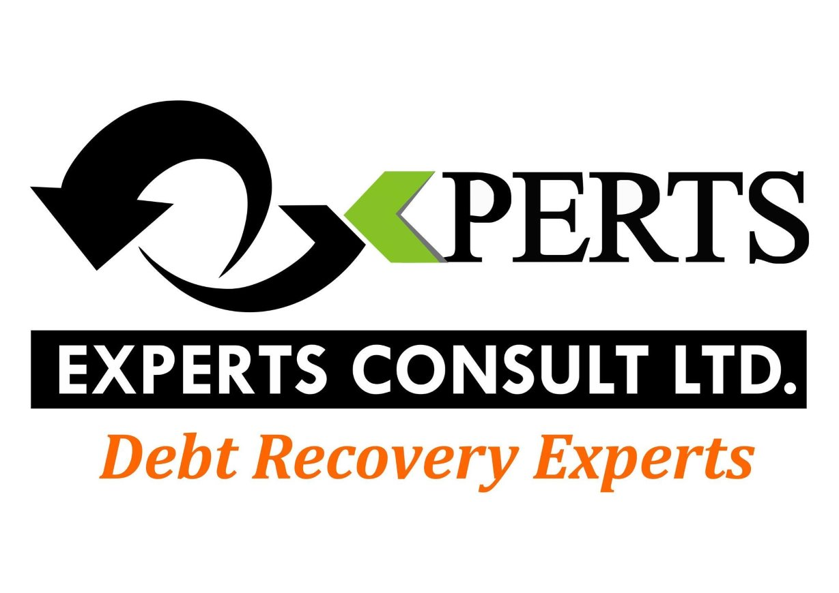
COMPANY OVERVIEW.
RECOVERING VALUE.
STRENGTHENING CASH FLOW.
PROFESSIONAL • RESPONSIBLE • TECHNOLOGY-ENABLED • RESULTS-DRIVEN • GLOBAL

₵  DEBT RECOVERY | ✓  CREDIT MANAGEMENT | ⚖  LEGAL RECOVERY | ⌂  ASSET TRACING

§  JUDGMENT ENFORCEMENT | ◎  RISK MONITORING | ↗  REVENUE COLLECTION | ⊕  GLOBAL RECOVERY

PEOPLE + PROCESS + TECHNOLOGY + LEGAL EXPERTISE + PERFORMANCE

◆ EXPERTS CONSULT LIMITED
▣ COMPANY OVERVIEW
Experts Consult Ltd is a Professional Debt Recovery, Credit Management and Financial Recovery Organization established under the laws of the Republic of Ghana with a clear mandate: to help financial Institutions, corporations, SMEs, businesses and individuals recover outstanding monies while preserving the commercial and professional relationships between creditors and their customers.
Since its establishment, Experts Consult has developed from a Ghana-focused recovery organization into an institution with regional and international capabilities.
The Company's current public profile identifies operations and coverage across Ghana, Kenya and Nigeria, supported by international relationships and its membership of the International Credit Exchange (ICE).
Experts Consult does not view debt recovery merely as the aggressive pursuit of overdue payments. It treats recovery as a structured financial-management process involving investigation, communication, negotiation, credit analysis, legal strategy, customer engagement, monitoring, enforcement and reporting.
The Company therefore operates across the wider receivables and credit-management lifecycle, helping clients not only recover money that is already overdue but also strengthen their credit-management practices and reduce future losses.

◆ Year of Incorporation and Establishment
Experts Consult was established in 2007. The Company's development since inception has been driven by the recognition that businesses need professional support to manage credit, monitor receivables AND recover funds that would otherwise become impaired or written off.
Over the years, the organization has developed experience across multiple sectors, including financial services, manufacturing, pharmaceuticals, telecommunications, utilities, trading, services and SMEs. Public profiles of the Company also describe its development into an international recovery

₵ Our Core Promise — "No Recovery, No Fee"
One of Experts Consult's distinctive client propositions is its "No Recovery – No Fee" model.
Under this proposition, the Company's commercial model is fundamentally aligned with the client's recovery outcome: where there is no recovery, the client does not pay a recovery fee, subject to the terms and conditions agreed for the specific assignment.
This creates a strong alignment of interests between Experts Consult and its clients.
Rather than charging clients simply for pursuing a case, the model places emphasis on:
Actual recovery results
Performance
Accountability
Efficient case management
Cost effectiveness
Client confidence
Measurable outcomes
The "No Recovery – No Fee" proposition is particularly attractive to organizations with large outstanding receivables portfolios because it can reduce the financial risk associated with outsourcing recovery activities.
⚖ Legal Recovery & Coordination
Enforcement support, Recovery monitoring, Client reporting.
The objective is to recover outstanding funds while avoiding unnecessary disruption to legitimate commercial relationships.
Client commitment is required at this stage; a little commitment fees as low as 1.5% to 3% is required (factors to be considered includes the amount to be recovered, location of the defaulter and age of the debt) from the client to climb the legal ladder, this fees caters for some part of court filing fees. Solicitors fee and all other incidental legal fees are paid by Experts Consult. This is to show our level of confidence in the Legal Recovery Stage.
✓ OUR INTERNATIONAL AFFILIATION — INTERNATIONAL CREDIT EXCHANGE
Experts Consult is a proud member of the International Credit Exchange (ICE).
Membership of ICE forms an important part of the Company's international recovery capability, enabling Experts Consult to connect with a wider network of recovery professionals and organizations when a debt involves a debtor, creditor, transaction or business relationship outside the Company's immediate geographical footprint.
The Company's historical public profile describes ICE as an international network connecting recovery firms across numerous jurisdictions and allowing member firms to support cross-border recovery assignments.
For Experts Consult, this international affiliation provides an important extension of its local capabilities.
A client may therefore engage Experts Consult for a receivable arising in Ghana while the debtor, company, asset or commercial relationship may be located in another country. Where appropriate, the matter can be coordinated through international partners and the applicable local legal and recovery framework.

◎ Value of ICE Membership
The Company's ICE membership supports:
Cross-border debt recovery
International case referrals
Access to recovery partners in other jurisdictions
Local-market assistance
International recovery coordination
Greater geographical reach
Knowledge sharing
International standards and professional practices
Support for multinational clients
This gives Experts Consult a broader proposition than a conventional domestic collection agency.

▦ OUR BUSINESS
Experts Consult operates at the intersection of:
Debt Recovery, Credit Management, Receivables Management, Risk Monitoring, Legal Recovery, Revenue Collection and Financial Intelligence.
The Company's objective is to help clients convert outstanding receivables into recovered cash while improving the systems and processes that govern credit.
◎ OUR SERVICES
₵ Commercial Debt Recovery
Experts Consult assists banks, corporations, businesses, trading organizations and other institutions in recovering outstanding commercial obligations.
The process can include:
Portfolio assessment
Account verification
Debtor profiling
Pre-legal recovery
Negotiation
Mediation
Payment-plan development
Settlement arrangements
Escalation where required

₵ DOMESTIC & CONSUMER DEBT RECOVERY
Experts Consult also provides recovery support for individual and household obligations.
Consumer recovery requires a different approach from commercial recovery. The Company therefore emphasizes appropriate communication, professionalism, empathy, documentation and compliance.
The process may include:
Account verification, Debtor contact, Payment discussions, Structured repayment arrangements, Follow-up, Settlement negotiation, Escalation where appropriate, Recovery confirmation, Reporting to the client.

The Company's stated approach is to pursue recovery while respecting debtor dignity and maintaining professional standards.
✓ CREDIT MANAGEMENT
Experts Consult recognizes that effective debt recovery begins long before a debt becomes overdue.
The Company therefore provides credit-management support designed to help organizations improve the quality of credit decisions and reduce avoidable future defaults.
Services may include Credit-policy review, Credit-process assessment, Customer assessment.

✓ Credit documentation review
Loan and contractual-document review
Credit-risk identification
Credit-control procedures
Receivables monitoring
Early-warning mechanisms
Portfolio monitoring
Credit-management training
Recovery-readiness assessment
The philosophy is straightforward:
Good credit management reduces bad debt; good recovery management minimizes losses when defaults occur.

◈ RISK MONITORING & RECEIVABLES MANAGEMENT
Experts Consult provides monitoring and management support designed to give clients greater visibility over their outstanding receivables.
The goal is to identify deteriorating accounts before they become significantly more difficult or expensive to recover.

⚖ LEGAL SUPPORT & ADVISORY
Debt recovery frequently involves legal questions concerning enforceability, documentation, contractual obligations and available remedies.
Experts Consult works with legal professionals and affiliated law firms to support matters requiring legal intervention.
The Company has an in-house Solicitors and partnerships with other legal professionals across its operating markets to support legally grounded recovery activities.

§ JUDGMENT ENFORCEMENT
Obtaining a court judgment does not necessarily mean that money has been recovered.
Experts Consult therefore supports clients and legal professionals with the practical enforcement and recovery process following judgments, subject to applicable law and procedure.
This can include:
§ Judgment follow-up
Debtor identification
Asset verification
Enforcement coordination

◎ PROCESS SERVICE
Experts Consult also provides process-serving capabilities.
This supports the legal and recovery ecosystem by assisting with the appropriate delivery and documentation of legal processes.
Experts consult currently operate in various Court in Ghana as Process Service Company for Judicial Service of Ghana, our Areas includes the Supreme Court, Court of Appeal in Accra, Some Circuit and District Courts in Kumasi and its environs.
The Company's historical public profile identifies process service as one of its established service areas.

₵ REVENUE COLLECTION
Experts Consult can also support organizations with structured revenue-collection requirements.
Potential applications include:
Outstanding service charges
◆ Commercial receivables
Customer balances
Institutional collections
Utility-related receivables
Telecommunications receivables
Other authorized revenue streams
The Company has historically described revenue collection as one of its service areas.

₵ Cross-Border Debt Recovery
International trade increasingly creates receivables involving parties in different countries.
Experts Consult's ICE membership and international relationships allow it to coordinate cross-border recovery matters where the relevant jurisdiction, debtor or asset is outside Ghana.
Cross-border assignments may involve:
Client → Experts Consult → International Network/Partner → Local Recovery/Legal Action → Reporting → Recovery
This enables clients to have a coordinated recovery interface rather than independently searching for collection agents in every jurisdiction.
International assignments remain subject to the laws, licensing requirements, privacy rules and professional standards applicable in the relevant jurisdictions.

▥ Industries We Serve
Experts Consult has experience and/or capabilities applicable to a broad range of sectors.
State Agencies
Banking & Financial Services
Manufacturing & Trading
Telecommunications
Utilities,
Pharmaceuticals & Healthcare
SMEs
Private Individuals

→ Our Modus Operandi
Experts Consult's recovery philosophy can be summarized as:

⚖ DATA , PEOPLE, TECHNOLOGY, LEGAL EXPERTISE, COMPLIANCE AND PERFORMANCE
Every assignment is managed through a structured recovery lifecycle.
◆ Step 1 — Client Instruction
The client provides the relevant account or portfolio information under an agreed engagement arrangement.

◆ Step 2 —Initial Assessment
Experts Consult conducts an initial assessment of the matter to understand:
Nature of the debt
Amount outstanding
Age of debt
Documentation
Debtor information
Previous recovery efforts
⚖ Legal considerations
Recovery prospects through legal means.
◆ Step 3 — Portfolio/Data Validation
Information is reviewed to determine whether the account is sufficiently documented and suitable for recovery action.
₵ Step 4 — Recovery Strategy
A strategy is developed according to the characteristics of the account.
The strategy may involve:
Direct engagement
Written demands
Negotiation
Mediation
Payment plans
Investigation
◆ Step 5 — Debtor Engagement
The debtor is approached through appropriate channels. The objective is not simply to demand payment, but to establish:
Ability to pay
Willingness to pay
Reasons for default
Disputes or documentation issues
Appropriate repayment options
Settlement possibilities
◆ Step 6 — Demand & Negotiation
Where appropriate, formal demands and negotiations are undertaken. The Company seeks commercially realistic solutions while protecting the client's interests.
⚖ Step 7 — Legal Escalation
Where voluntary recovery is unsuccessful and legal action is appropriate, the matter may be escalated through the relevant legal process.
₵ Step 8 — Recovery
Once payment is obtained, the recovery is documented, reconciled and reported to the client.
⌘ Our Technology & Reporting Approach
Experts Consult has historically emphasized technology and client visibility in its operations.
IT has an operating Management Application that allows clients to monitor cases, view progress and payments, receive updates and provide feedback.

★ Our Achievements
Established in March, 2007, Experts Consult has accumulated more than 19 years of experience in debt recovery and credit management. This experience represents one of the Company's most important competitive assets: practical knowledge developed through years of dealing with real-world credit and recovery challenges.
Experts Consult’s membership with the International Credit Exchange (ICE) is particularly significant because it provides an international dimension to the Company's recovery capability and supports cross-border case handling.
Professional Recognition
Experts Consult and its leadership have also received public recognition within Ghana's credit-management and debt-recovery sector. The Company's leadership was associated with recognition including Best Debt Recovery Agency of the Year awards in consecutive years from 2020, 2021, 2022, 2023 and 2024.
These recognitions provide external evidence of the Company's standing within the Ghanaian credit-management and debt-recovery ecosystem.

◆ Our Competitive Advantage
Experts Consult's competitive position is based on a combination of capabilities rather than a single service.
◆ 1. Established Track Record
Since 2007, the Company has accumulated extensive practical experience in debt recovery and credit management.
₵ 2. No Recovery – No Fee
The Company's performance-based proposition aligns its commercial interests with successful client recovery.
◎ 3. International Reach
ICE membership and international relationships extend the Company's ability to support cross-border recovery.
⚖ 4. Legal Capability
The Company has an in-house legal department whose duty is to climb the legal step. It works with other legal professionals and law-firm partners to support matters requiring legal intervention our of its operating jurisdictions

◆ 5. Multi-Sector Experience
Experts Consult serves or has experience relevant to financial services, manufacturing, telecommunications, utilities, pharmaceuticals, SMEs, trading and other sectors.
◆ 6. Human Expertise
Experienced recovery professionals, legal specialists, investigators, client-service personnel and management provide the human foundation of the business.
⌘ 7. Technology & Transparency
Digital case management, reporting and analytics can give clients greater visibility over recovery activities.
◆ 8. Relationship Preservation
The Company's philosophy emphasizes recovery while protecting legitimate client-customer relationships.
◆ 9. End-to-End Capability
Experts Consult can support a matter from:
Credit Management → Risk Monitoring → Early Intervention → Debt Recovery → Legal Recovery → Judgment Enforcement → Reporting
This integrated approach distinguishes the Company from firms that provide only one component of the recovery process.

↗ 20. OUR VALUE PROPOSITION TO CLIENTS
Experts Consult offers clients a comprehensive recovery proposition:
"You focus on your core business. We focus on recovering your money."
Clients benefit from the ability to outsource difficult receivables while retaining visibility and control.
The ultimate objective is to turn outstanding receivables into cash, information and improved credit discipline.
Experts Consult's proposition is to establish a professional recovery pipeline through which qualifying receivables are identified, validated, segmented, pursued and recovered.

THE INTEGRATED RECOVERY ECOSYSTEM

₵  RECOVER | ✓  MANAGE | ⚖  ENFORCE | ◎  MONITOR | ↗  GROW

EXPERTS CONSULT LIMITED IS THE RIGHT PARTNER TO ALL DEBT RECOVERY NEEDS
Debt Recovery • Credit Management • Receivables Management • Legal Recovery • Judgment Enforcement • Global Recovery
EXPERTS CONSULT LIMITED
NPL Resolution | Debt Recovery | Credit Management | Enforcement Support
Tel: +233 302 223353 • Email: info@expertsconsultgh.co • Website: www.expertsconsultgh.co
FROM DISTRESSED ASSETS TO RECOVERED CASH.

CONTACT DETAILS
ADDRESS: NO. 43, Royalt Castle Road
Kokomlemle, Accra
TEL.
Office Line: +233 302 223 353
Mobile Line: +233 248 296 082/0244 630 026
Email: info@expertsconsultgh.co
Website: www.expertsconsultgh.co

