  STRATEGIC NPL  REDUCTION & DEBT  RECOVERY PARTNERSHIP  PROPOSAL  Supporting Financial Institutions to Reduce Non-Performing Loans, Improve Cash Recovery and Strengthen Asset Quality  TURN NPLs INTO RECOVERIES.  TURN RECOVERIES INTO LIQUIDITY.  PROTECT THE BALANCE SHEET.  DEVELOPED BY : EXPERTS CONSULT LIMITED | EXPERTS

From Distressed Assets to Recovered Cash.

EXECUTIVE PROPOSAL
A Strategic Response to the NPL Challenge

The growing regulatory and commercial pressure on financial institutions to reduce Non-Performing Loans (NPLs) requires a decisive shift from conventional debt collection to structured, measurable and professionally managed recovery.  Experts Consult Limited proposes a strategic partnership to accelerate the recovery and resolution of delinquent and non-performing credit facilities.  Our outsourced recovery platform combines professional negotiation, debtor engagement, restructuring support, asset tracing, legal recovery coordination and enforcement of judgments.  Our role is to complement internal Credit, Risk and Recovery teams by taking responsibility for selected difficult portfolios and driving them toward measurable resolution. | TURN NPLs INTO  RECOVERIES  ↓  TURN RECOVERIES  INTO LIQUIDITY  ↓  PROTECT THE  BALANCE SHEET

THE REGULATORY IMPERATIVE
The Bank of Ghana has intensified its focus on the level of NPLs within Ghana’s financial sector. Current supervisory measures are aimed at reducing the stock of problem assets and strengthening credit-risk management across regulated financial institutions.
Profitability | Liquidity | Capital & provisioning | Lending capacity
Operational efficiency | Asset quality | Shareholder value | Financial-system stability
For financial institutions, NPL reduction is not merely a recovery-department function. It is a strategic balance-sheet priority.

OUR PROPOSED SOLUTION

The Experts NPL Reduction Programme

A five-stage portfolio-management approach designed to move accounts from diagnosis to recovery, settlement, enforcement and transparent reporting.
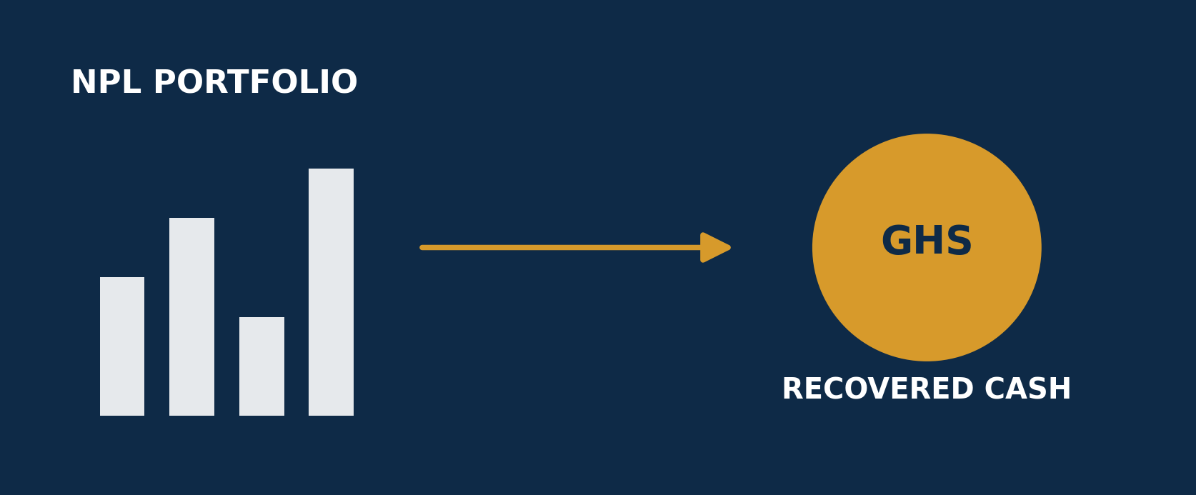
01 | PORTFOLIO DIAGNOSTIC  Review and segment delinquent accounts into Recoverable, Restructurable, Enforcement-ready, Asset-backed and Difficult/Legacy categories.

02 | RAPID RECOVERY  Immediate debtor engagement, demand and negotiation, settlement arrangements, repayment proposals, guarantor engagement, asset verification, skip tracing and intensive follow-up.

03 | RESTRUCTURING & SETTLEMENT  Facilitate commercially reasonable settlement or restructuring recommendations for viable borrowers, always subject to the client’s prior approval.

04 | LEGAL RECOVERY & ENFORCEMENT  Escalate suitable matters through lawful legal processes and help move existing judgments from order to enforcement and recovery.

05 | REPORTING & PORTFOLIO INTELLIGENCE  Provide structured reporting on assigned amount, cash recovered, balance, status, action taken, next action and expected recovery.

EXECUTION & ENFORCEMENT
Recovery First. Litigation Where Necessary.
The preferred pathway is consensual recovery wherever commercially possible. Where recovery fails and legal escalation becomes necessary, Experts Consult coordinates the transition through appropriate legal and enforcement processes.
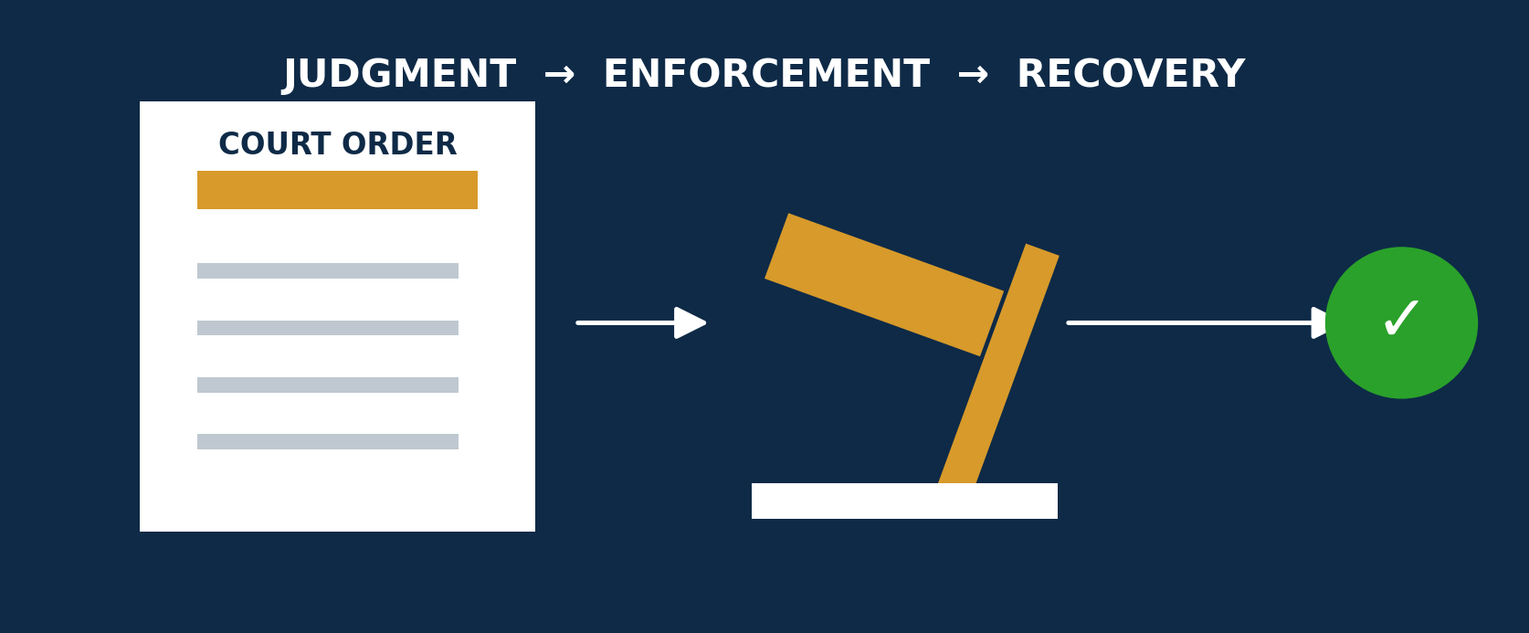
RAPID RECOVERY  • Debtor engagement  • Demand & negotiation  • Settlement arrangements  • Structured repayment proposals  • Corporate debtor & guarantor engagement  • Asset and business verification  • Skip tracing where required  • Intensive follow-up | LEGAL & ENFORCEMENT SUPPORT  • Pre-enforcement case review  • Legal recovery coordination  • Judgment-enforcement planning  • Process serving support  • Asset verification  • Execution follow-through  • Status escalation  • Recovery reporting
PORTFOLIO INTELLIGENCE

Visibility. Control. Accountability.



Management should not have to chase a recovery company for information. Experts Consult will provide structured real-time reporting that allows the institution to track performance across every assigned account. Our online access to viewing progress of account referred by your institution would be provided; this would allow management access to progress of account referred to Experts Consult as and when required.
Amount Assigned | Amount Recovered | Outstanding Balance | Recovery Rate
Account Status | Action Taken | Next Action | Expected Recovery

The result: full portfolio visibility, clear accountability, and better information for management decisions.

IMMEDIATE ACTION PROGRAMME
The 90-Day NPL Recovery Accelerator

For institutions seeking rapid action, Experts Consult proposes an initial 90-Day NPL Recovery Accelerator Programme with agreed performance indicators.
DAYS 1–15 | Portfolio onboarding, verification, debtor classification and recovery strategy.

DAYS 16–30 | Intensive debtor engagement, negotiations and settlement discussions.

DAYS 31–60 | Recovery, restructuring recommendations and escalation of difficult accounts.

DAYS 61–90 | Aggressive follow-up, enforcement recommendations and portfolio performance review.

At the end of 90 days, management receives a comprehensive recovery report, portfolio performance analysis and recommendations for the remaining accounts.
START WITH A PILOT PORTFOLIO
Assign a selected portfolio. Agree the KPIs. Test our performance over 90 days. Expand the relationship based on demonstrated results.
Cash Recovered | Recovery Rate | Speed | Reporting | Compliance | Professionalism

STRATEGIC PARTNERSHIP
Why Outsource NPL Recovery?

Outsourcing does not mean surrendering control. The institution retains control; Experts Consult provides specialist recovery capacity.
✓ Increase recovery capacity without significantly increasing permanent staff | ✓ Attack legacy NPL portfolios aggressively
✓ Introduce specialist recovery expertise | ✓ Separate difficult debtor negotiations from normal customer-facing operations
✓ Improve recovery accountability | ✓ Reduce the cost of prolonged internal recovery
✓ Accelerate conversion of distressed assets into cash | ✓ Allow management and credit teams to focus on core banking activities

PERFORMANCE-DRIVEN COMMERCIAL MODEL
A substantial component of Experts Consult’s remuneration can be linked to actual amounts successfully recovered, aligning our commercial incentive with the institution’s outcome. A strictly performance based remuneration (Commission based Fee Structure)

FEE SHEDULE IS SHOWN BELOW
COMMISSIONS APPLICABLE | PRE-LEGAL | LEGAL
All Amounts Exceeding GHc 10,000,000.00 | 8% | 10%
All Amounts Exceeding GHc 5,000,000.00 But Does Not Exceed GHc 9,999,999.00 | 10% | 13%
All Amounts Exceeding GHc 1,000,000.00 But Does Not Exceed GHc 4,999,999.00 | 10% | 15%
All Amounts below GHc 500,000.00 But Does Not Exceed GHc 999,999.00 | 12% | 18%
All Amounts below GHc 500,000.00 | 15% | 20%

The fees schedule describes the commission applicable if success is achieved at either Pre-Legal Recovery (Without legal intervention) or Legal recovery.

WHEN OUR CLIENT SUCCEEDS, EXPERTS CONSULT SUCCEEDS.

INSTITUTIONAL STANDARDS
Confidentiality, Governance & Reputational Protection

Debt recovery in the financial sector involves sensitive customer, institutional and legal information. All engagements will operate under agreed confidentiality, data-protection, governance and reporting arrangements.
PROFESSIONALISM | Firm, respectful and commercially aware debtor engagement.

CONFIDENTIALITY | Controlled handling of customer and institutional information.

ACCOUNTABILITY | Clear ownership, reporting and escalation on every assigned case.

COMPLIANCE | Recovery activity aligned with applicable law and client procedures.

REPUTATIONAL PROTECTION | Effective recovery without unnecessary damage to viable customer relationships.

Recovery should be firm and effective, but never careless with the institution’s reputation.

ABOUT US
Explore Experts Consult Limited

EXPERTS CONSULT LIMITED (ECL) is a Ghanaian-owned professional debt recovery, credit management and enforcement services company established in 2007. Headquartered in Accra, the company has built close to two Decades of experience providing structured, ethical and results-driven recovery solutions to financial institutions, corporate organisations, SMEs and individuals.  Experts Consult specializes in commercial and consumer debt recovery, credit management, legal recovery and enforcement, judgement enforcement, process serving, skip tracing and asset verification, risk monitoring and related advisory services. Its recovery approach combines negotiation and settlement with legal and enforcement mechanisms where necessary, while seeking to preserve the commercial relationships between clients and their customers.  Over the years, Experts Consult has developed considerable experience serving clients across sectors including banking and finance, manufacturing and trading, telecommunications, utilities and other corporate sectors. The company states that it has handled recoveries exceeding GHS1 billion and served more than 1,000 clients, supported by trained recovery professionals and legal partners.  Beyond Ghana, Experts Consult is developing its cross-border debt recovery capabilities, with operations and networks extending to Kenya and Nigeria and International recovery support through professional and legal partnerships. The company is also a member of the International Credit Exchange (ICE), supporting its commitment to international standards, compliance and ethical recovery practices.  Our Mission: To deliver transparent, efficient and fair debt recovery solutions that safeguard clients' financial interests while preserving valuable business relationships.  Our Vision: To become a leading African and international debt recovery and credit management institution, combining professional expertise, technology, legal capability and international partnerships to provide effective recovery solutions across borders.  Core Values: Integrity • Professionalism • Accountability • Transparency • Efficiency • Results.  Experts Consult Limited — Your Partner in Debt Recovery, Credit Management and Financial Recovery. | MESSAGE FOR CEO  Strengthening Financial Institutions Through Professional Recovery  Financial institutions are fundamental to economic growth. However, the strength of every credit institution depends not only on its ability to lend, but also on its ability to recover.  Non-performing loans, overdue facilities and unrecovered receivables tie up valuable capital, weaken liquidity, increase impairment pressures and ultimately restrict the ability of financial institutions to extend new credit to productive businesses and individuals.  At Experts Consult Ltd, we believe debt recovery should therefore be treated as an integral part of credit risk management, not simply as an action taken when everything else has failed.  Experts Consult provides structured recovery solutions covering portfolio recovery, commercial debt recovery, receivables management, negotiation and restructuring support, asset tracing, legal recovery coordination and execution of court judgments.  Our approach combines professional human engagement with technology, data analytics and the development of AI-enabled recovery solutions. Our objective is not merely to pursue debtors, but to recover value responsibly, protect institutional relationships and help restore financial assets to productive use.  We invite financial institutions to view Experts Consult as an extension of their credit and recovery operations. Whether the challenge involves a single high-value exposure or a substantial portfolio of delinquent accounts, we are prepared to develop a recovery strategy aligned with the institution’s objectives, governance requirements and risk framework.  The future of sustainable lending depends on responsible credit creation and equally responsible recovery.  Let us recover what is owed, restore liquidity and strengthen the financial system together.  .
CORE CAPABILITIES
Commercial Debt Recovery | Credit Management | Legal Recovery Coordination | Judgment Enforcement Support
Process Serving | Skip Tracing & Verification | Risk Monitoring | Portfolio Recovery Strategy

WE ARE NOT PROPOSING ANOTHER CONSULTANCY REPORT.
WE ARE PROPOSING RECOVERY.
Experts Consult is prepared to sit with your Credit, Risk, Recovery, Finance, Legal and Management teams, examine the institution’s NPL challenges and agree on portfolios where specialist intervention can produce measurable results.
RECOVER MORE | RECOVER FASTER | REDUCE NPLs | IMPROVE LIQUIDITY | PROTECT ASSET QUALITY
PROPOSED NEXT STEP
We respectfully request an opportunity to make a short presentation to the institution’s Managing Director/CEO, Chief Risk Officer, Head of Credit, Head of Recoveries, Chief Finance Officer and Legal Department.
Following the presentation, the institution may identify a pilot portfolio for immediate assessment and recovery.

EXPERTS CONSULT LIMITED
NPL Resolution | Debt Recovery | Credit Management | Enforcement Support
Tel: +233 302 223353 • Email: info@expertsconsultgh.co • Website: www.expertsconsultgh.co
FROM DISTRESSED ASSETS TO RECOVERED CASH.

CONTACT DETAILS
ADDRESS: NO. 43, Royalt Castle Road
Kokomlemle, Accra

TEL.
Office Line: +233 302 223 353
Mobile Line: +233 248 296 082
Email: info@expertsconsultgh.co
Website: www.expertsconsultgh.co

